**Guide to Creating Certificate for RDS**

This document aims to act as a guide to creating a proper certificate for RDS. Microsoft RDS Certificates need to be created with certain names or it simply doesn’t work. RDS has 2 locations that need to have certificates. 1 on the broker and 1 on the web/gateway. It’s easier to create and manage with just 1 certificate rather than 2.

**Certificate Requirements:**

**Name:**

Per Microsoft documentation: For 5 or less in the RDS farm you can go with

For 6 or more in the Farm (it’s better to use a wildcard)

Name:

Web/Gateway frontend url fqdn (alias to server name like rdweb.domain.com)

web/gateway Server fqdn

web/Gateway Server fqdn (if you need it)

Broker fqdn

Session1 host fqdn

Session1 host fqdn

*If you are using a high availability broker that will also need an alias created from the teamed machines.*

**Subject Alternative Name (Should/must match Name)**

Copy Exactly as the name field:

See example below of a custom certificate request from Windows.:

**Under the Subject Tab**

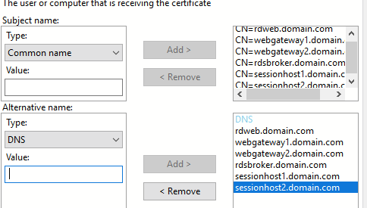

Below is an example of one using a wild card with a high availability broker. Rds.domain.com is the alias.

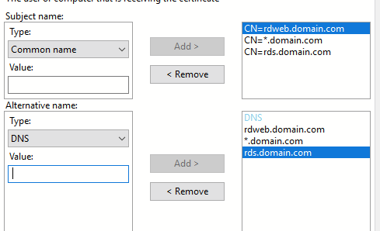

**Under the Extensions Tab**

Certificate Key Usage should be Digital Signature and Key Encipherment

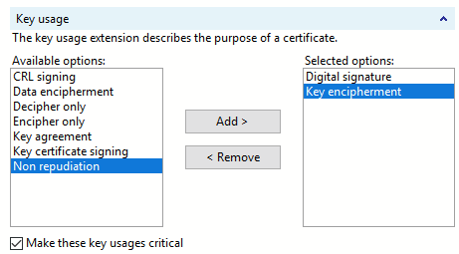

Extended Key Usage should be Server Authentication

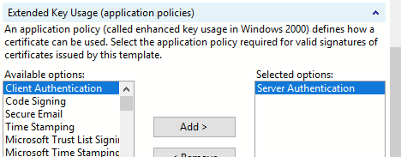

**Under the Private Key Tab**

Cryptographic Service Provider should be Microsoft’s most modern one:

RSA Microsoft Software Key Storage Provider

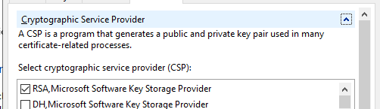

Key length should be a Minimum of 2048 and make the key exportable

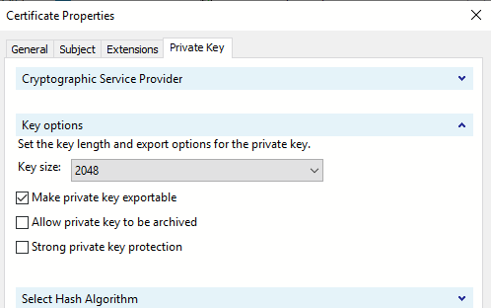

Hash Algorithm should be Sha256

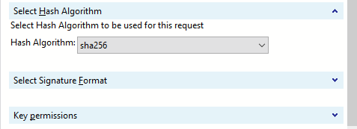

When getting the key install it onto your system.

Run MMC.exe and add certificates, Select Computer Account

Locate the certificate under Personal and copy the serial number.

Open command prompt and run the following to get your certificate’s private key:

Certutil -repair my “serial number”

Export this to a .pfx for Use for RDS.